QuickBooks® Business Accounting Software 2007 & 2009-2010 for Mac®
Account Conversion Instructions for Web Connect
 | As your financial institution its system conversion, you will need to modify your QuickBooks settings to ensure the smooth transition of your data. You will need to be able to log in to the Web sites of your financial institution. This update may be time sensitive.  It is important that you perform the following instructions exactly as described and in the order presented. If you do not, your online banking service may stop functioning properly. This conversion should take about 15 minutes.  Note: In the following screen shots, red icon numbers match step number instructions. All bank and register information is fictitious and for illustration only.   Within this guide, this symbol displays to indicate any optional instructions.

A. |  | BACK UP YOUR CURRENT DATA
- Choose File menu → Back Up. Then choose whether to save the backup to a disk or to your Mac.
- Follow the on-screen instructions to complete the backup method you choose.

B. |  | GET YOUR LATEST TRANSACTIONS
 |  | - Download your transactions one last time to bring your account register up to date. Log in to the Web site and download and save your Web Connect file (.QBO file extension) to your Mac.  Important: Specify your transaction download date range through today. You may not be able to download these transactions after today.  - In QuickBooks, choose Banking menu → Downloaded Transactions.  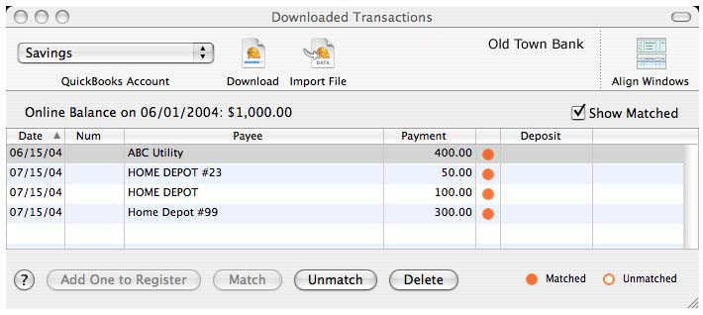  - In the Downloaded Transactions dialog, click Import File to import the account information contained in the Web Connect file that you saved. Select the Web Connect file, and click Open.  - Add or match all downloaded transactions listed in the Downloaded Transactions dialog. You will not be able to proceed until all transactions are matched.  - Once all downloaded transactions are matched and display a solid orange circle, click Delete to remove each item.  Repeat steps 1 through 5 for each account (such as checking, savings, and credit cards) that you plan to use for online banking.  For assistance reconciling your account register, choose Help menu → QuickBooks Help. In the Ask a Question prompt, enter Reconciling an account.

C. |  | DISABLE YOUR ACCOUNTS FROM WEB CONNECT
- Choose Lists menu → Chart of Accounts.
- Select the account to disable in the Chart of Accounts list, and choose Edit menu → Edit Accounts.

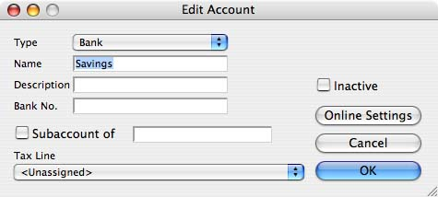
- If necessary, edit the Name and Routing Number of the account in the Edit Account dialog.
- Click the Online Settings button.
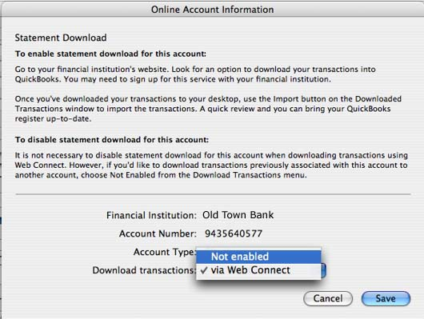

- Select Not enabled from the Download transactions drop-down list.
- Click Save.
Repeat steps 2 through 6 for each account from which you download transactions.

D. |  | RE-ENABLE YOUR ACCOUNTS FOR WEB CONNECT
IMPORTANT: Do not complete section D until after the conversion.
- Re-enabling your account is as easy as downloading from the Web site. Anytime after the conversion, log in to the Web site and download and save your Web Connect file (.QBO file extension) to your Mac.
Important: To avoid the possibility of creating duplicate records when downloading into QuickBooks, select a “from” date that does not include records previously downloaded.
2. In QuickBooks, choose Banking menu → Downloaded Transactions.
Click OK if any informational prompts display.
- In the Downloaded Transactions dialog, click Import File to import the account information contained in the Web Connect file that you saved. Select the Web Connect file, and click Open.

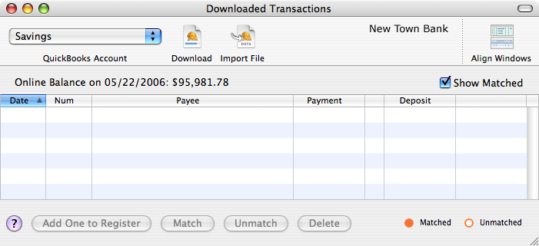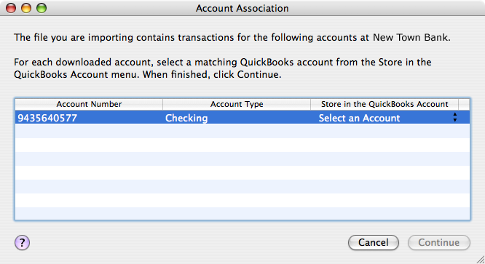
- The Account Association dialog displays during setup only. Click Select an Account to choose to map the online account to an existing account register. Then click Continue.
- Click OK to any informational prompts.
Repeat steps 1 through 5 for each account that you previously disabled.
- Verify that all transactions downloaded successfully into your account registers.
THANK YOU FOR MAKING THESE IMPORTANT CHANGES!

